Capstone Project Report
Predicting and Grouping Penguin Species with Python
Yuva Intern / NSDC - Virtual Data Science with Python - Week 6: Integrative Capstone Project

Item | Details
Dataset | Palmer Penguins (public dataset, seaborn / seaborn-data on GitHub)
Tools | Python, pandas, NumPy, Matplotlib, Seaborn, Scikit-learn, SciPy
Techniques | EDA, K-Means, PCA, Hierarchical clustering, Logistic Regression, KNN, Random Forest, Gradient Boosting
Code | Week6_Capstone_Penguins.ipynb (runs from start to end, fixed random state 42)

1. Problem Statement
Penguins of different species look similar, and a researcher in the field would like to identify the species quickly from simple measurements. In this project I use the Palmer Penguins dataset to answer two questions:
- Supervised question: can the species (Adelie, Chinstrap or Gentoo) be predicted from bill length, bill depth, flipper length, body mass, island and sex?
- Unsupervised question: if the species labels are ignored, do the measurements still form natural groups, and do those groups match the real species?
The goal is to show that I can design and run a complete data science pipeline on my own: data collection, cleaning, exploratory analysis, modelling, evaluation and recommendations.

2. Methodological Approach
Step | What was done
1. Data collection | Load the public Palmer Penguins dataset and inspect it
2. Data cleaning | Check missing values, duplicates and outliers and decide how to handle each
3. EDA | Distributions, box plots, pair plot, correlation heatmap, island and sex analysis
4. Unsupervised learning | Scale features, K-Means (elbow and silhouette), PCA, hierarchical clustering
5. Supervised learning | Stratified 80/20 split, preprocessing pipeline, 4 classifiers, 5-fold cross validation, GridSearchCV
6. Evaluation | Accuracy, precision, recall, F1, confusion matrix, repeated cross validation, feature importance
7. Insights | Conclusions, limitations, recommendations and reflection

Two choices were made to keep the evaluation honest. First, the imputer, scaler and encoder are placed inside a Scikit-learn Pipeline so they learn only from training data (no data leakage). Second, the final model is chosen using cross validation scores on the training data and the test set is used only once at the end.

3. Data Collection
The Palmer Penguins dataset is publicly available and is distributed with the seaborn library (source: the seaborn-data repository on GitHub). It was loaded with seaborn and saved as penguins.csv so the notebook also runs offline. The raw data has 344 rows and 7 columns.
Column | Type | Description
species | Category | Adelie, Chinstrap or Gentoo (target for classification)
island | Category | Biscoe, Dream or Torgersen
bill_length_mm | Numeric | Length of the bill
bill_depth_mm | Numeric | Depth of the bill
flipper_length_mm | Numeric | Length of the flipper
body_mass_g | Numeric | Body mass in grams
sex | Category | Male or Female

if os.path.exists("penguins.csv"):
df = pd.read_csv("penguins.csv")
else:
df = sns.load_dataset("penguins")
print("Shape:", df.shape)

4. Data Cleaning
Missing values in the raw data:
Column | Missing values
bill_length_mm | 2
bill_depth_mm | 2
flipper_length_mm | 2
body_mass_g | 2
sex | 11

I also checked duplicates and outliers. The decisions are:
- Two rows have no measurements at all (and no sex). They carry no information, so they were dropped. The dataset now has 342 rows.
- The 9 remaining missing values are all in the sex column. I kept these rows and fill them with the most frequent value inside the modelling pipeline, learned from training data only.
- Duplicate rows: 0. Nothing to remove.
- Outliers: I used the IQR rule (1.5 x IQR) on the four numeric columns and found 0 outliers in each, so nothing was removed. This suggests the values are real measurements without typing errors.
all_missing = df[num_cols].isnull().all(axis=1)
df_clean = df[~all_missing].copy().reset_index(drop=True)
# outliers with the IQR rule
q1, q3 = df_clean[col].quantile(0.25), df_clean[col].quantile(0.75)
iqr = q3 - q1
n_out = ((df_clean[col] < q1 - 1.5*iqr) | (df_clean[col] > q3 + 1.5*iqr)).sum()
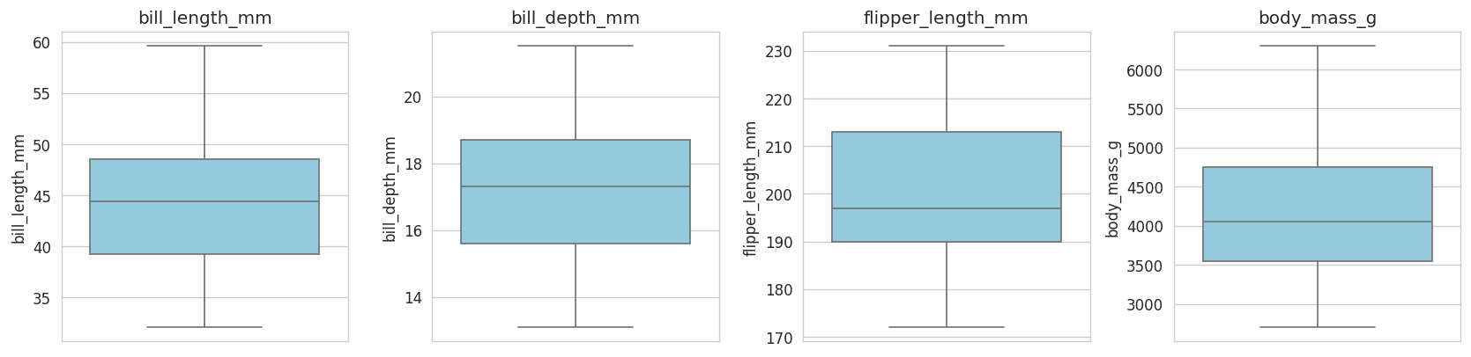
Figure 1: Box plots of the four measurements (no outliers found)

5. Exploratory Data Analysis
The dataset has 151 Adelie, 123 Gentoo and 68 Chinstrap penguins. The classes are not perfectly balanced, so I used stratified splitting and looked at precision, recall and F1 and not only accuracy.
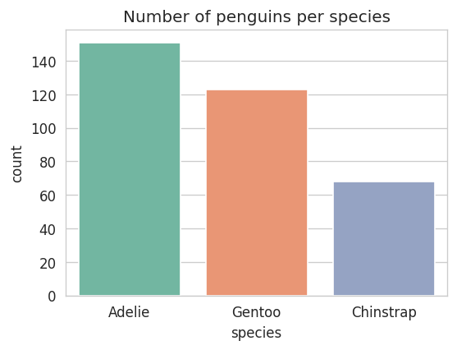
Figure 2: Number of penguins per species

5.1 Distributions and species differences
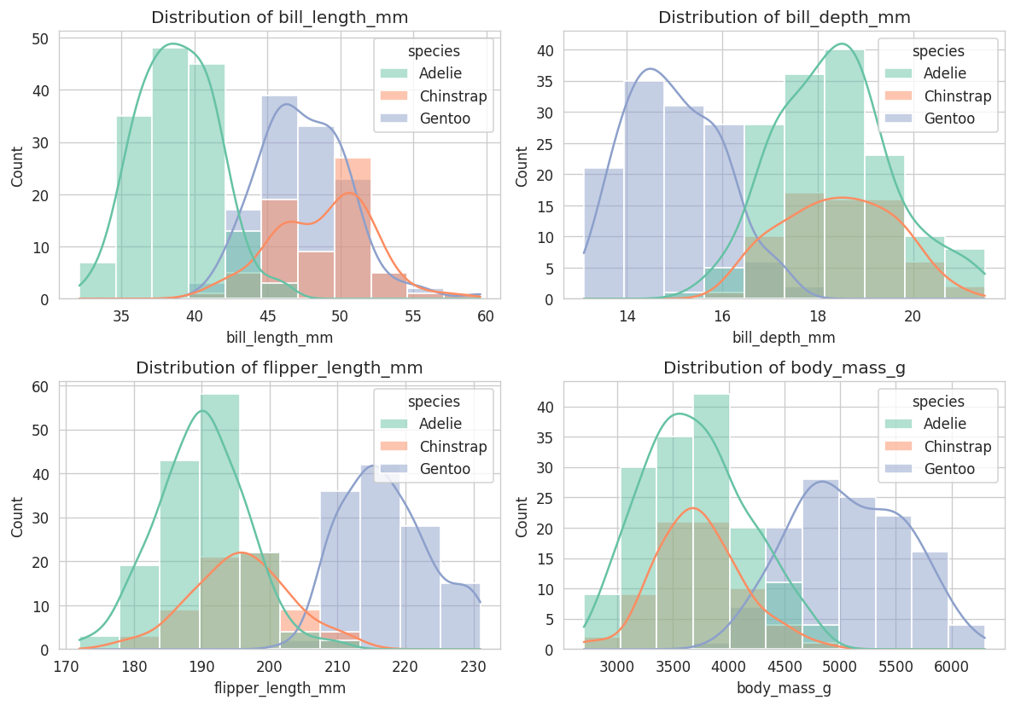
Figure 3: Distribution of each measurement by species
Species | Bill length (mm) | Bill depth (mm) | Flipper (mm) | Body mass (g)
Adelie | 38.8 | 18.3 | 190.0 | 3700.7
Chinstrap | 48.8 | 18.4 | 195.8 | 3733.1
Gentoo | 47.5 | 15.0 | 217.2 | 5076.0

Gentoo penguins are clearly different: they are much heavier (about 5076 g against about 3700 g) and have longer flippers and a shallower bill. Adelie and Chinstrap have almost the same body mass and flipper length, but Chinstrap has a much longer bill (about 48.8 mm against 38.8 mm).
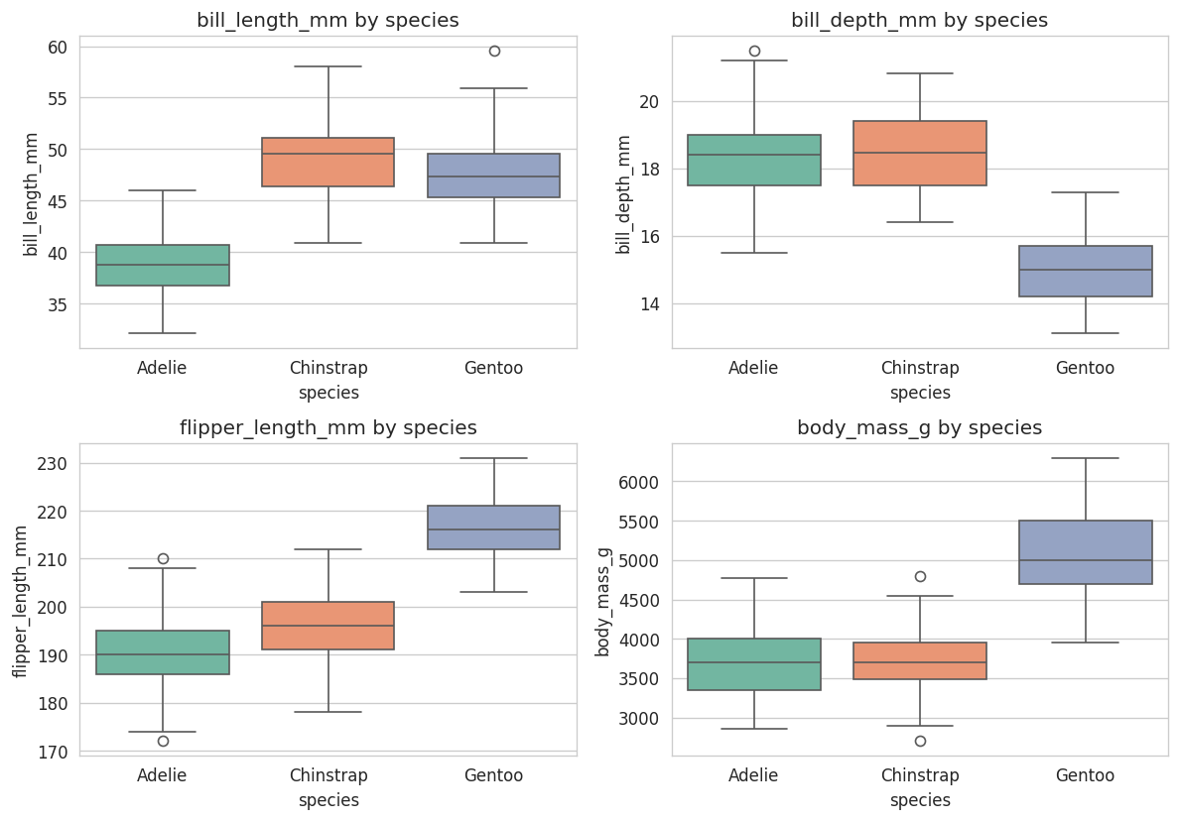
Figure 4: Box plots of each measurement by species

5.2 Relationships between features
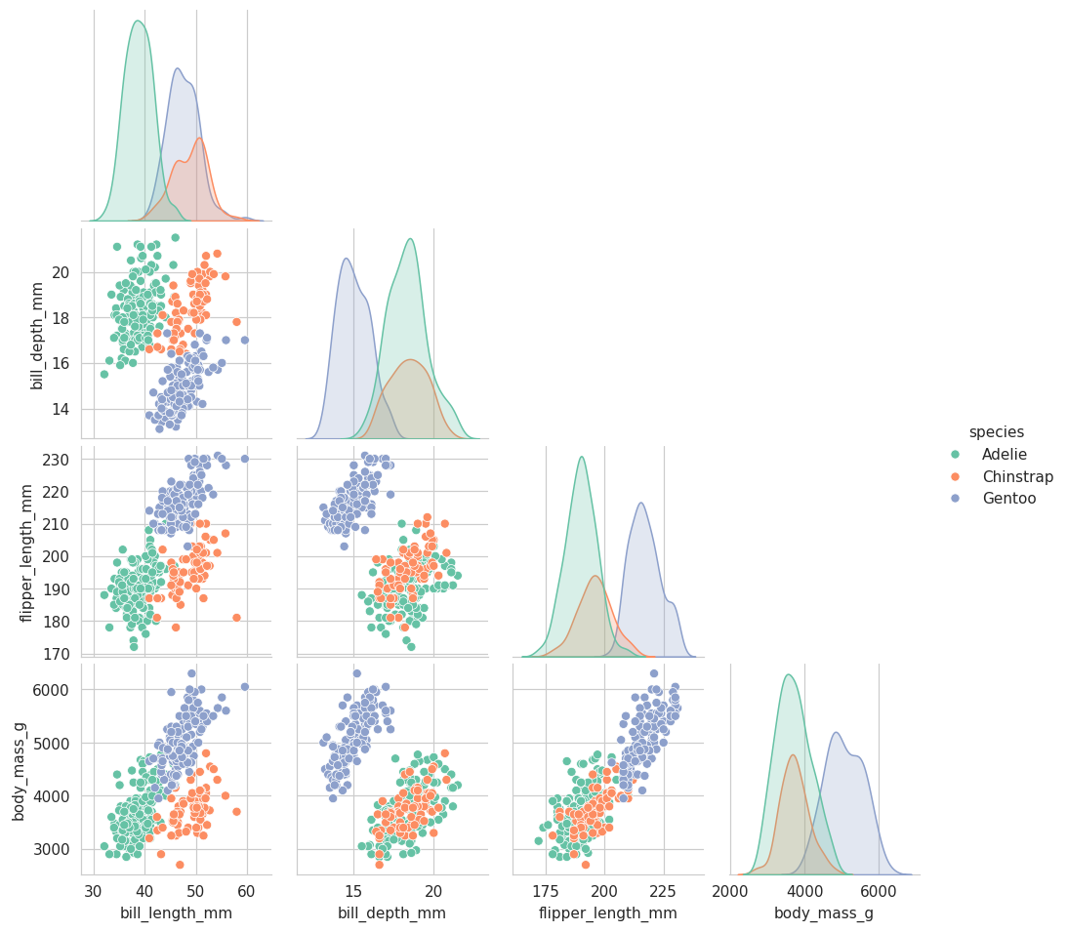
Figure 5: Pair plot of the numeric features coloured by species
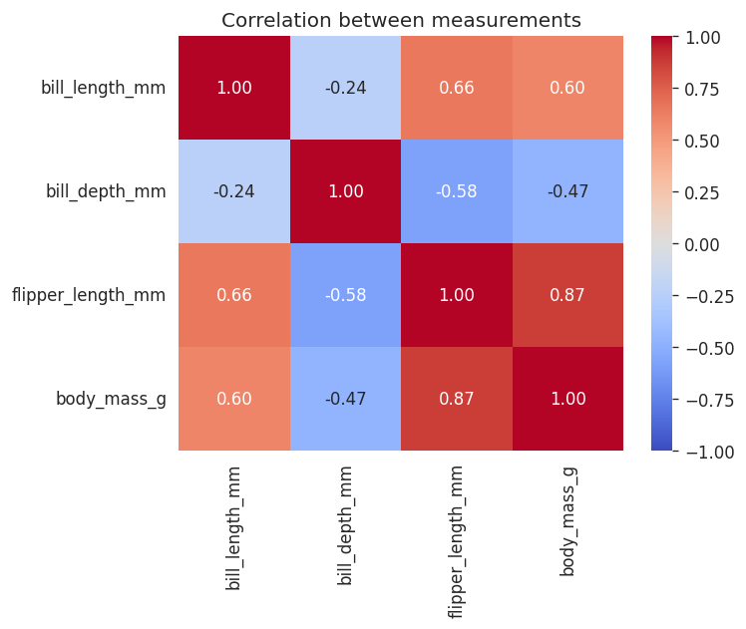
Figure 6: Correlation heatmap
Flipper length and body mass have a strong positive correlation (0.87). Bill depth has a negative correlation with flipper length (-0.58) because Gentoo has long flippers but a shallow bill. Because flipper length and body mass carry similar information, their importance is shared in the models later.

5.3 Island and sex
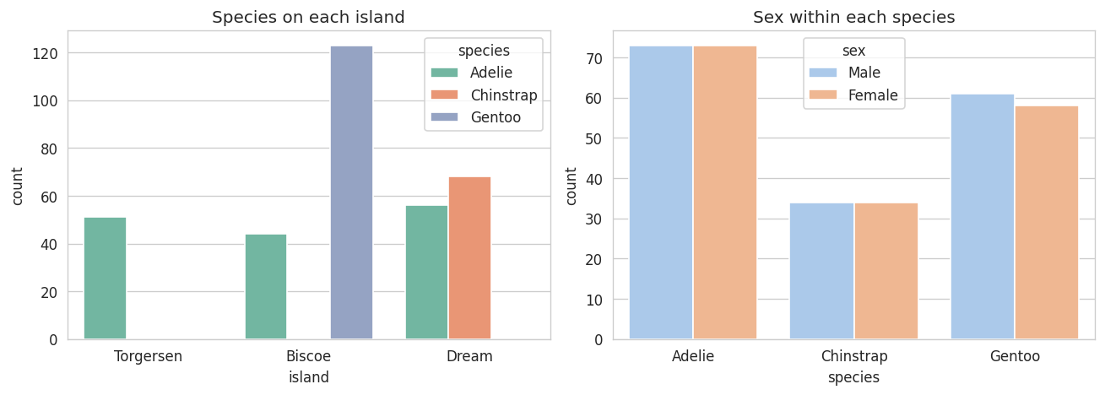
Figure 7: Species on each island and sex within each species
Island is closely linked to species: all 123 Gentoo live on Biscoe, all 68 Chinstrap live on Dream, while Adelie is found on all three islands. Within every species males are heavier than females (for example Gentoo males about 5485 g and females about 4680 g), so sex explains variation inside a species but not between species.

Key findings from EDA
- Gentoo is easy to separate from the other two species.
- Adelie and Chinstrap overlap in body size, and bill length is the feature that separates them best.
- Island is almost a shortcut for species, which I discuss later as a limitation.

6. Modelling

6.1 Unsupervised learning
Here I ignore the species labels and use only the four numeric measurements. The features were standardised first, because K-Means and hierarchical clustering use distances and body mass (in grams) would otherwise dominate.
X_scaled = StandardScaler().fit_transform(df_clean[num_cols].values)
for k in range(2, 9):
km = KMeans(n_clusters=k, n_init=10, random_state=42).fit(X_scaled)
inertias.append(km.inertia_)
sil_scores.append(silhouette_score(X_scaled, km.labels_))

K-Means and choosing k
k | Inertia | Silhouette score
2 | 565.7 | 0.532
3 | 379.4 | 0.447
4 | 300.4 | 0.4
5 | 232.6 | 0.379
6 | 204.4 | 0.368
7 | 187.0 | 0.331
8 | 171.0 | 0.296

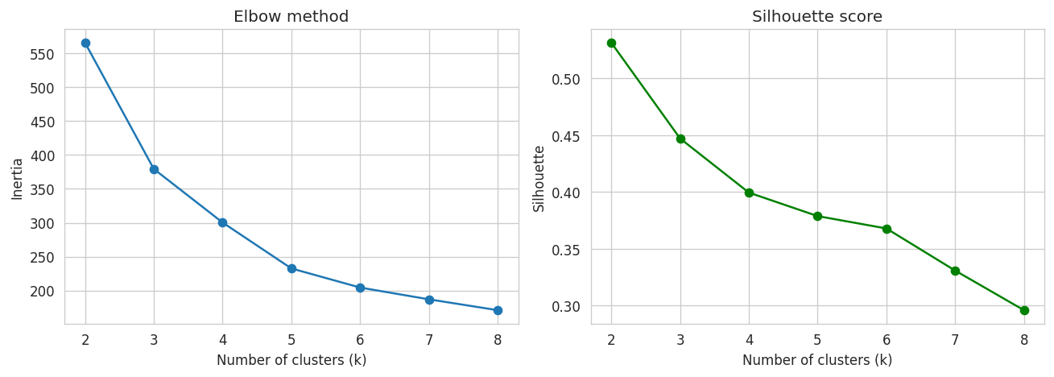
Figure 8: Elbow method and silhouette score for k = 2 to 8
The silhouette score is highest at k = 2 (0.532) because Gentoo is so different from the other two species. I also tested k = 3 and compared the clusters with the real species using the adjusted rand index (ARI). K-Means with k = 2 has ARI 0.655 and with k = 3 has ARI 0.793 (silhouette 0.447). Since k = 3 matches the species better, I used k = 3 for the rest of the analysis.
True species | Cluster 0 | Cluster 1 | Cluster 2
Adelie | 24 | 0 | 127
Chinstrap | 63 | 0 | 5
Gentoo | 0 | 123 | 0

Cluster 1 contains exactly the 123 Gentoo penguins. Cluster 2 is mostly Adelie (127 of 151) and cluster 0 is mostly Chinstrap (63 of 68), but 24 Adelie penguins are placed in the Chinstrap cluster and 5 Chinstrap in the Adelie cluster.

PCA
PCA with two components explains 68.8% (PC1) and 19.3% (PC2) of the variance, about 88.1% in total, so a 2D plot keeps most of the information. PC1 is mainly a size component (flipper length 0.58, body mass 0.55) and PC2 is mainly about the bill (bill depth 0.80, bill length 0.60).
pca = PCA(n_components=2, random_state=42)
X_pca = pca.fit_transform(X_scaled)
print(pca.explained_variance_ratio_)
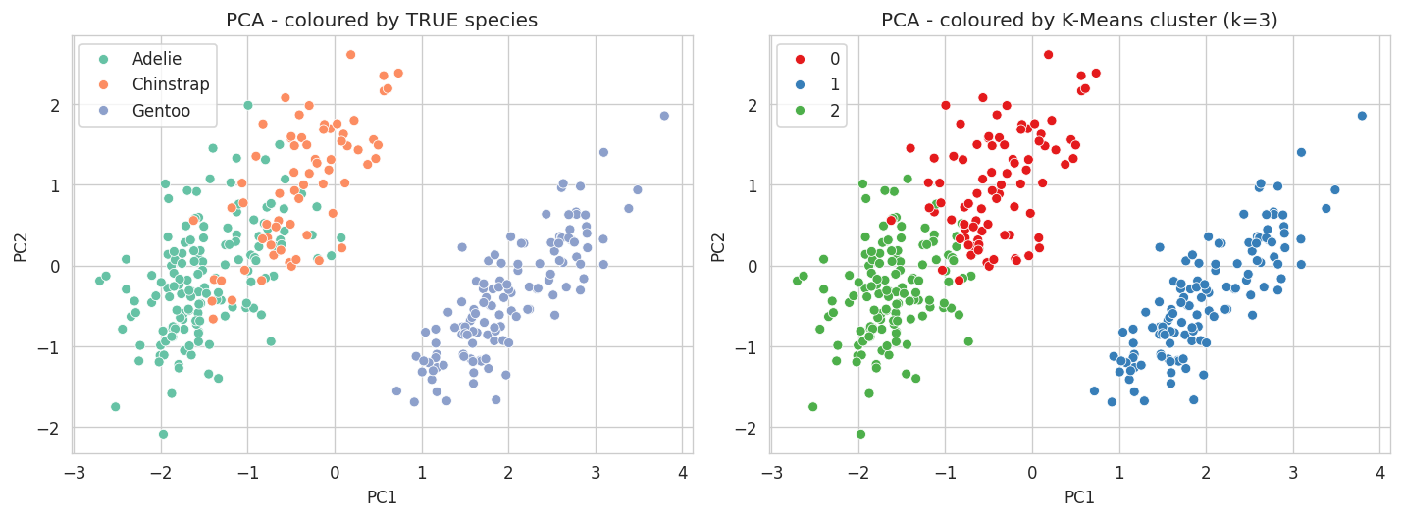
Figure 9: PCA plot coloured by true species (left) and by K-Means cluster (right)

Hierarchical clustering
I used agglomerative clustering with Ward linkage and k = 3. It gave a silhouette score of 0.454 and an ARI of 0.916, which is better than K-Means (ARI 0.793).
True species | Cluster 0 | Cluster 1 | Cluster 2
Adelie | 151 | 0 | 0
Chinstrap | 11 | 0 | 57
Gentoo | 0 | 123 | 0

Z = linkage(X_scaled, method="ward")
agg = AgglomerativeClustering(n_clusters=3, linkage="ward").fit(X_scaled)
print(adjusted_rand_score(y_species, agg.labels_))
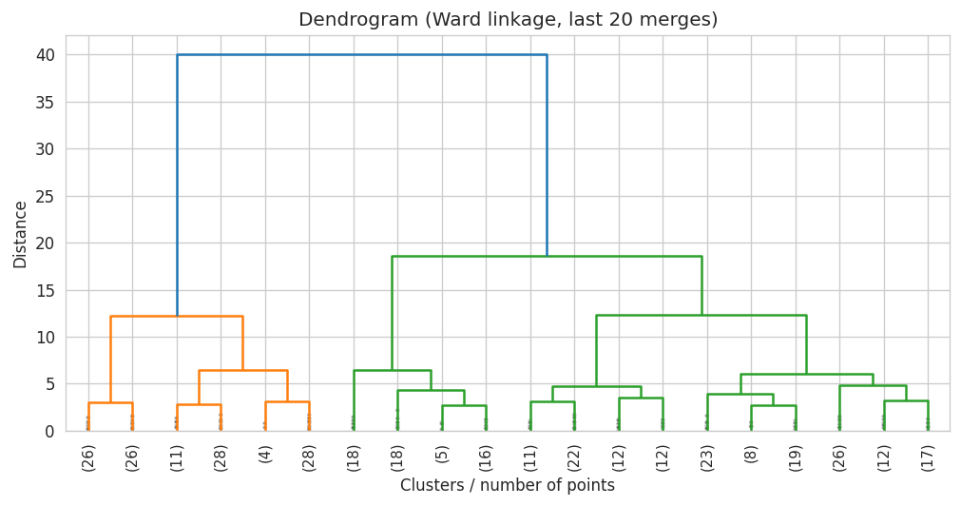
Figure 10: Dendrogram (Ward linkage, last 20 merges)
Conclusion of the unsupervised part: the measurements form natural groups. Gentoo separates perfectly in both methods, and the only confusion is between Adelie and Chinstrap. Only 11 Chinstrap penguins are put in the Adelie cluster by hierarchical clustering, so it is the better method on this dataset.

6.2 Supervised learning (classification)
The target is species and the features are the four measurements plus island and sex. The data was split 80/20 with stratification (273 training rows and 69 test rows). Numeric columns use median imputation and standard scaling, categorical columns use most-frequent imputation and one-hot encoding, all inside one pipeline.
X_train, X_test, y_train, y_test = train_test_split(
X, y, test_size=0.2, stratify=y, random_state=42)
preprocessor = ColumnTransformer([
("num", Pipeline([("imputer", SimpleImputer(strategy="median")),
("scaler", StandardScaler())]), num_cols),
("cat", Pipeline([("imputer", SimpleImputer(strategy="most_frequent")),
("onehot", OneHotEncoder(handle_unknown="ignore"))]), cat_cols),
])

Four models compared with 5-fold cross validation
Model | CV accuracy (mean) | CV std
Logistic Regression | 0.9927 | 0.009
KNN | 0.9853 | 0.0138
Random Forest | 0.9818 | 0.0199
Gradient Boosting | 0.978 | 0.0138

cv = StratifiedKFold(n_splits=5, shuffle=True, random_state=42)
for name, model in models.items():
pipe = Pipeline([("prep", preprocessor), ("model", model)])
scores = cross_val_score(pipe, X_train, y_train, cv=cv, scoring="accuracy")

Hyperparameter tuning
I used GridSearchCV on Logistic Regression (C from 0.01 to 100) and Random Forest (number of trees, max depth, min samples split). The best Logistic Regression had C = 1 with CV accuracy 0.9927. The best Random Forest used 100 trees, no depth limit and min samples split 2, with CV accuracy 0.9818.
grids = {
"Logistic Regression": {"model__C": [0.01, 0.1, 1, 10, 100]},
"Random Forest": {"model__n_estimators": [100, 200],
"model__max_depth": [None, 3, 5],
"model__min_samples_split": [2, 5]},
}
gs = GridSearchCV(pipe, grid, cv=cv, scoring="accuracy", n_jobs=-1)

7. Evaluation
Model | Accuracy | Precision (macro) | Recall (macro) | F1 (macro)
Logistic Regression (tuned) | 1.0 | 1.0 | 1.0 | 1.0
KNN | 1.0 | 1.0 | 1.0 | 1.0
Random Forest (tuned) | 1.0 | 1.0 | 1.0 | 1.0
Gradient Boosting | 1.0 | 1.0 | 1.0 | 1.0

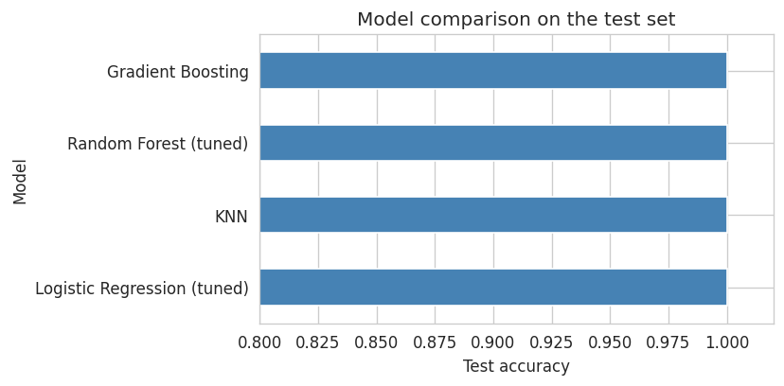
Figure 11: Test accuracy of all models
All four models reach 100% on the test set. The test set has only 69 penguins, so this does not prove one model is better than another. The cross validation scores (0.978 to 0.993) are a better basis for comparison, and the differences between them are small, about one penguin per fold. The final model was chosen by the cross validation score and not the test score, so Logistic Regression (tuned) was selected. It is also simple, fast and easy to explain.
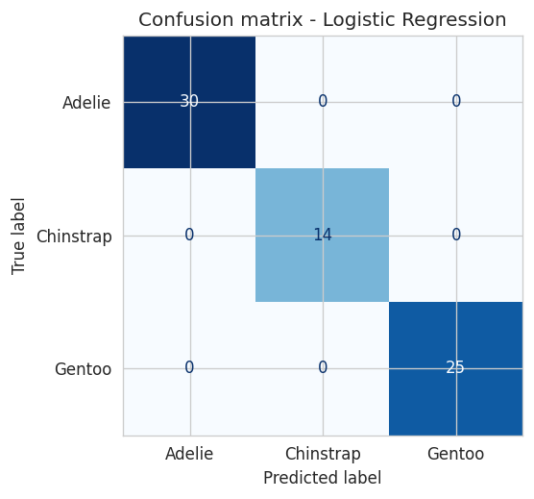
Figure 12: Confusion matrix of the final model on the test set
The confusion matrix has only values on the diagonal (30 Adelie, 14 Chinstrap and 25 Gentoo correctly classified), so there are no wrong predictions on the test set.
Because a perfect test score on 69 rows can be lucky, I also ran repeated 5-fold cross validation (5 repeats) on all the data. The accuracy was 99.4% with a standard deviation of 0.7%. This is the more realistic estimate: on new penguins I would expect roughly 99% accuracy, with a few mistakes, most likely between Adelie and Chinstrap.
rcv = RepeatedStratifiedKFold(n_splits=5, n_repeats=5, random_state=42)
all_scores = cross_val_score(clone(final_pipe), X, y, cv=rcv, scoring="accuracy")
print(all_scores.mean(), all_scores.std())

Feature importance
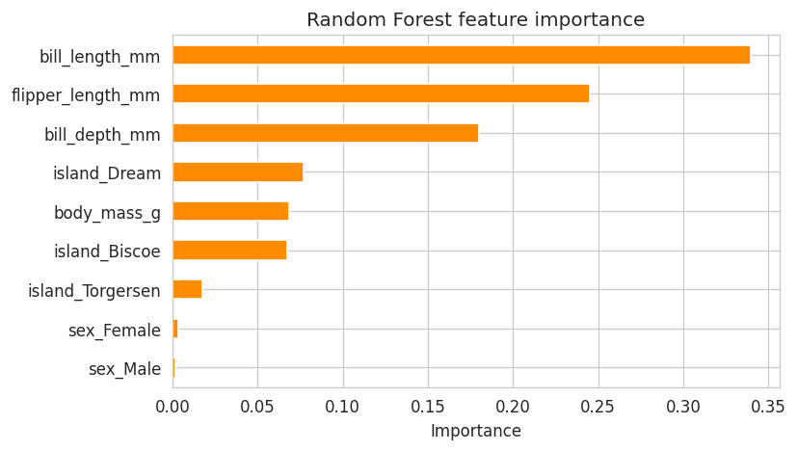
Figure 13: Random Forest feature importance
Bill length (0.339), flipper length (0.245) and bill depth (0.18) are the most important features. Body mass has a lower importance (0.069) even though Gentoo is much heavier, because it is strongly correlated with flipper length and the two share the credit. The island columns add up to about 0.16, which fits the fact that Chinstrap lives only on Dream and Gentoo only on Biscoe. Sex is almost unused (about 0.005 in total), because it changes size inside a species but does not decide the species.

8. Insights and Recommendations
- Penguin species can be predicted from simple body measurements with about 99% accuracy. Bill length and flipper length are the most useful features.
- A field researcher could identify the species from just a bill and flipper measurement, without any expensive method.
- A simple model (Logistic Regression) works as well as more complex ones (Random Forest, Gradient Boosting), so the simple model is the better choice here: it is fast, easy to explain and less likely to overfit on a small dataset.
- If the measurement is only for identifying Gentoo, a simple threshold on flipper length or body mass would be enough. Extra care is needed only for Adelie versus Chinstrap, where bill length is the key.

Limitations
- The dataset is small (342 penguins) and the species are quite different, so this is an easy classification problem. The results may not hold for harder problems.
- The 100% test accuracy comes from a test set of only 69 rows. The repeated cross validation result (about 99.4%) is more realistic.
- Island is almost a shortcut for species, so a model that depends on it may fail for penguins from a new location.
- The data comes from three islands and a few years only, so it may not represent all penguin populations.

What further analysis could be done
- Train the models without the island feature to check how well the species can be predicted from body measurements alone.
- Try other models such as SVM, and compare models with statistical tests instead of only looking at mean scores.
- Use the same data for a regression task, for example predicting body mass from flipper length and bill size.
- Collect more data from more islands and years to test whether the model generalises.

9. Reflection: Challenges and Successes

Challenges
- Choosing the number of clusters was not straightforward. The silhouette score was highest at k = 2 (0.532), but k = 3 matched the real species better (ARI 0.793 against 0.655), so I had to explain both choices instead of trusting one number.
- Avoiding data leakage: I put imputation, scaling and encoding inside a Pipeline so that they are fitted only on the training folds.
- A test accuracy of 100% looked suspicious at first. I dealt with it by using cross validation and repeated cross validation and by explaining that the small test set is the reason.

Successes
- The full pipeline runs from start to end in one notebook and gives the same results every time because the random state is fixed.
- The unsupervised and supervised results agree with each other: Gentoo is easy to separate, while Adelie and Chinstrap are the only pair that overlaps.
- The feature importance results agree with what I saw in the EDA plots, so the analysis is consistent from the beginning to the end.

10. References
- Horst AM, Hill AP, Gorman KB (2020). palmerpenguins: Palmer Archipelago (Antarctica) penguin data. R package version 0.1.0. Data originally collected by Dr. Kristen Gorman and the Palmer Station LTER.
- Seaborn data repository (penguins.csv): https://github.com/mwaskom/seaborn-data
- Scikit-learn documentation: https://scikit-learn.org

